1. Installation

Prerequisites:

SharePoint set to Class Experience

1. Index.html
2. event-registration.js
3. event-registration.min.js
4. eventreg-config.json

Step 1)

Go to the SharePoint site where the app will be located and click Site contents -> Site Assets and create a new folder called “Event-Registration”

Step 2)

Upload all prerequisite files.

Step 3)

Click the Settings gear icon -> Site contents -> Site Pages -> New -> Web Part Page

Step 4)

Name the file. \*It is recommended to use era.aspx and set the Layout Template to Full Page, Vertical

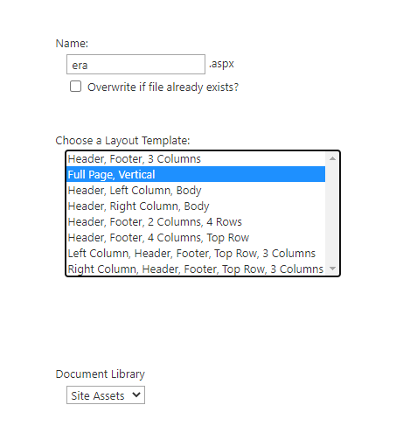

Step 5)

Click Add a Web Part. Under Categories choose Media and Content. Make sure Content Editor is chosen under Parts. And click add.

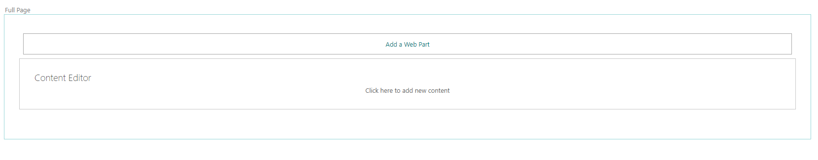

Step 6)

In the upper right hand corner of Content editor click the dropdown arrow -> Edit Web Part

Step 7)

Enter the URL from the top collection site to the index.html file in the Event-Registration folder.

Expand Layout and set Chrome Type to None.

Step 8)

Click Install on the appearing dialog.

Step 9)

Click Refresh when it appears on the dialog box

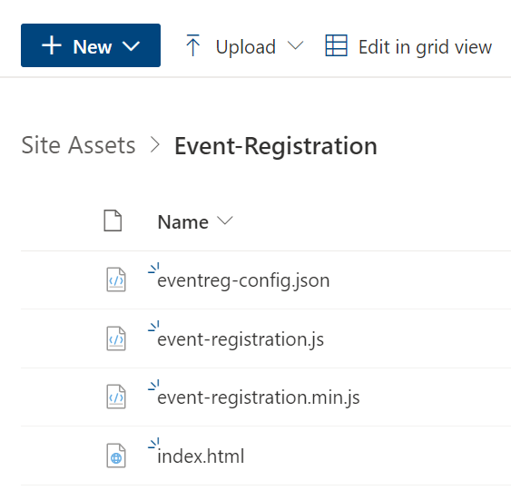

1. Create folder for project named Event-Registration on SP site
2. 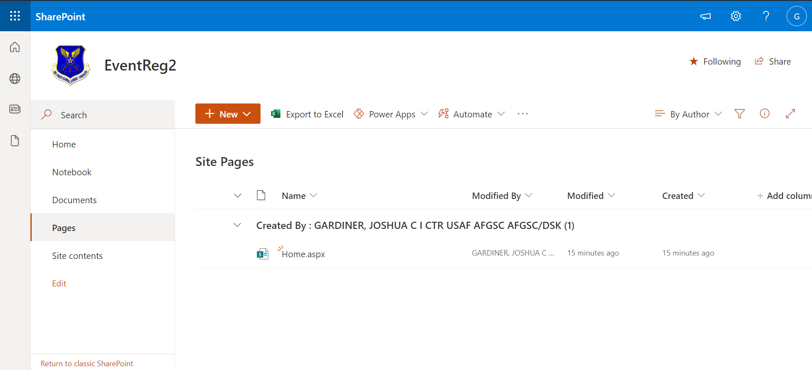

7) Upload event-registration.js and event-registration.min.js form dist directory

8) Upload index.html and event-config.json files from assets to directory

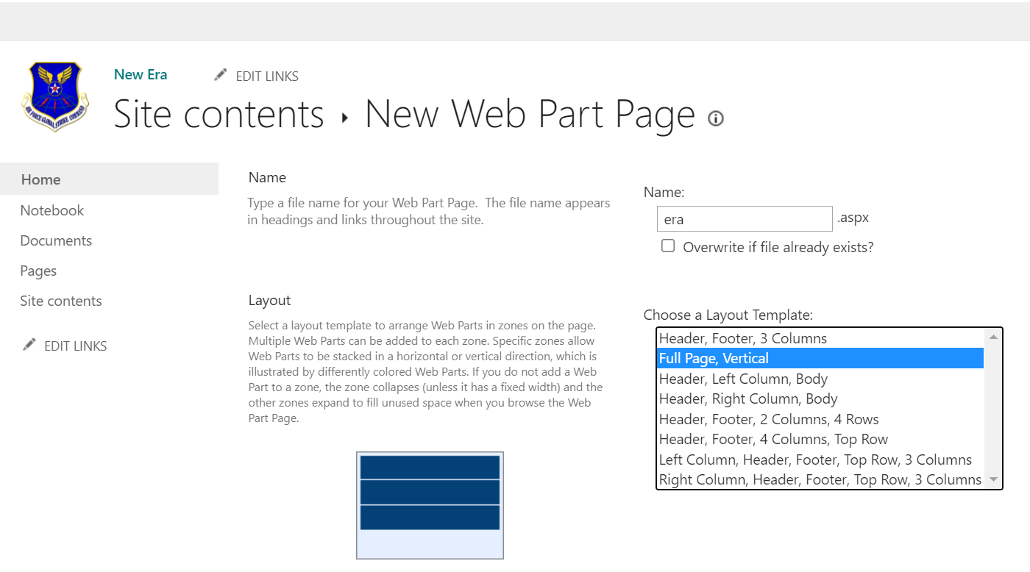

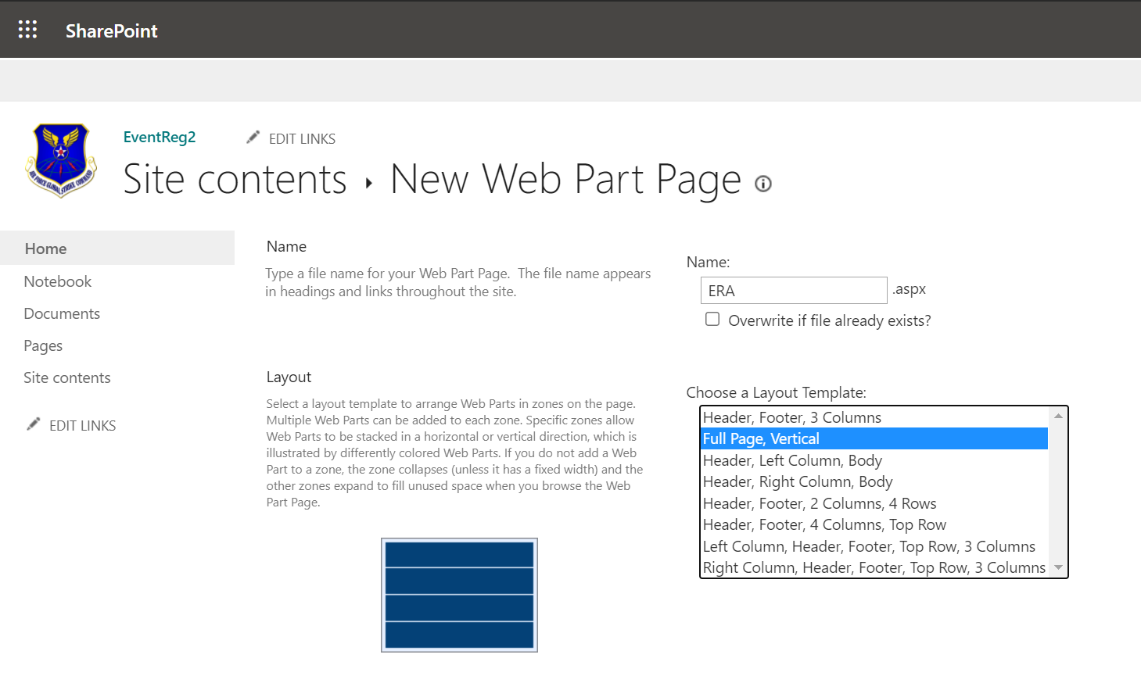

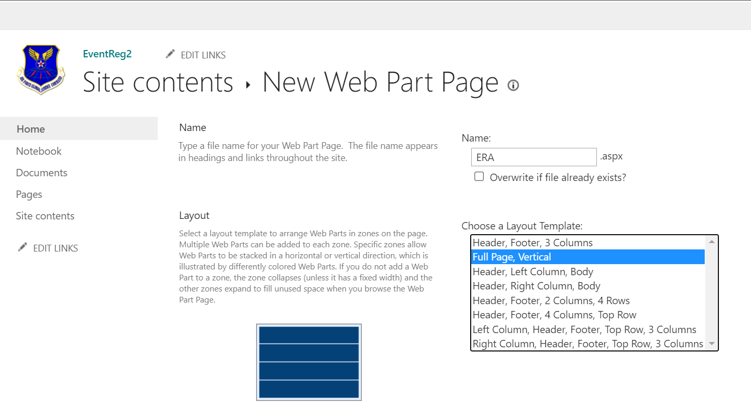

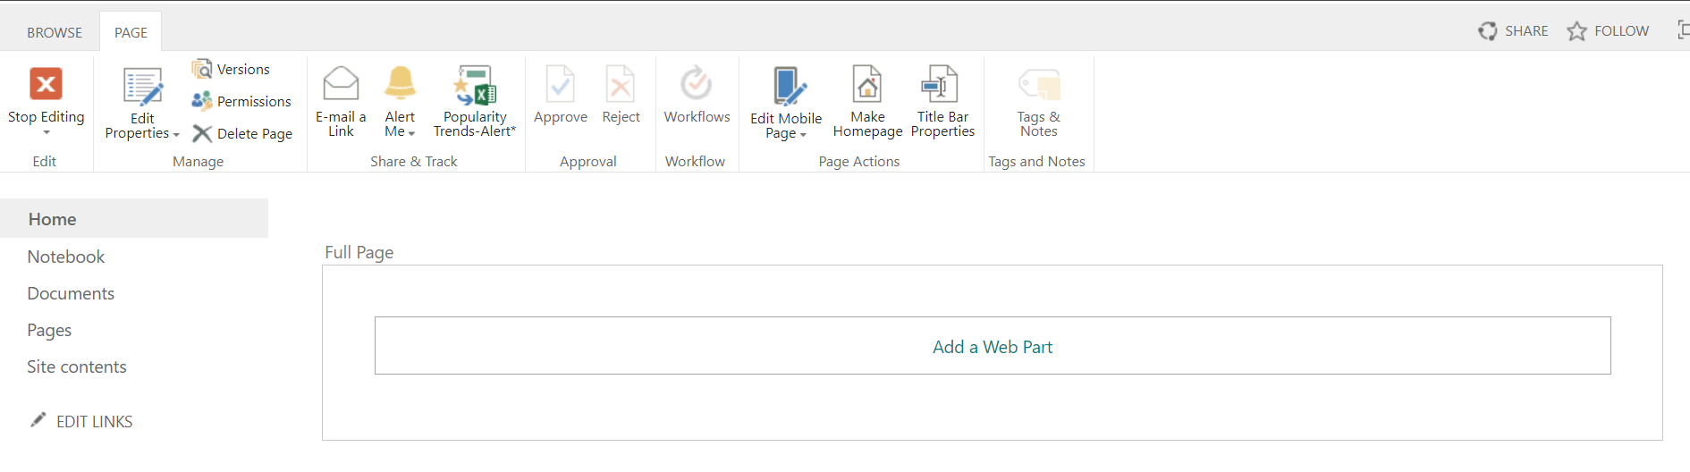

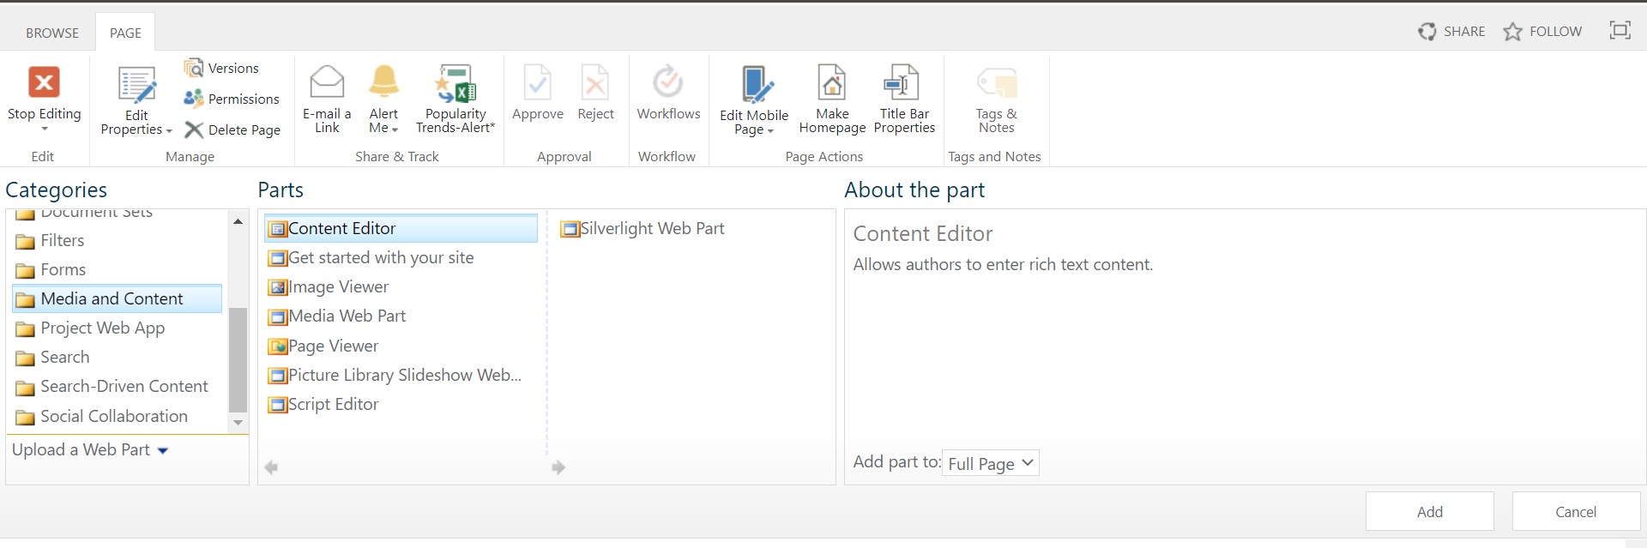

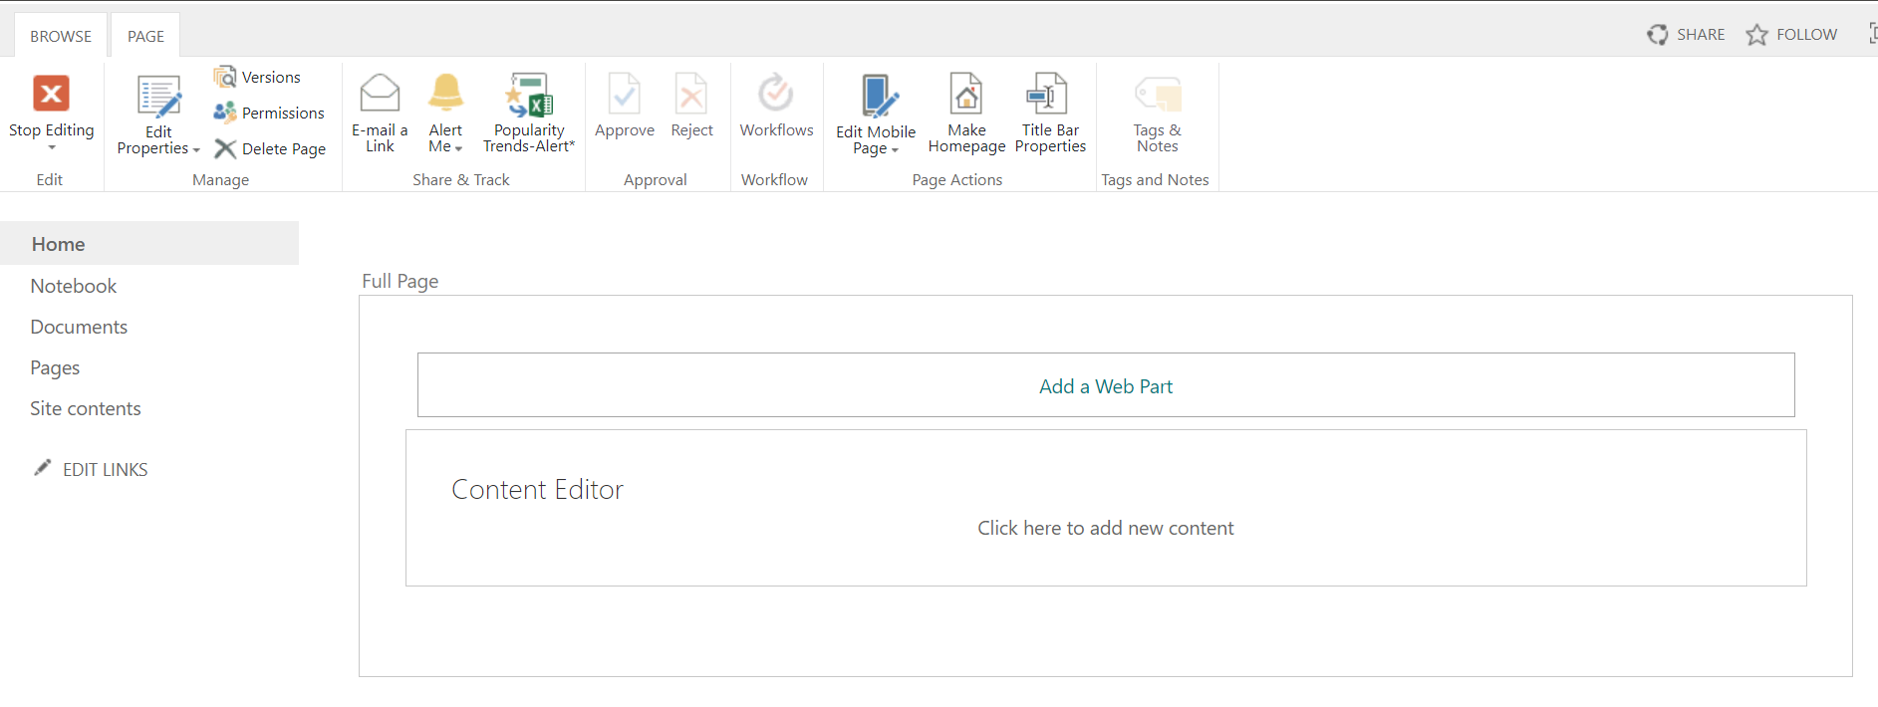

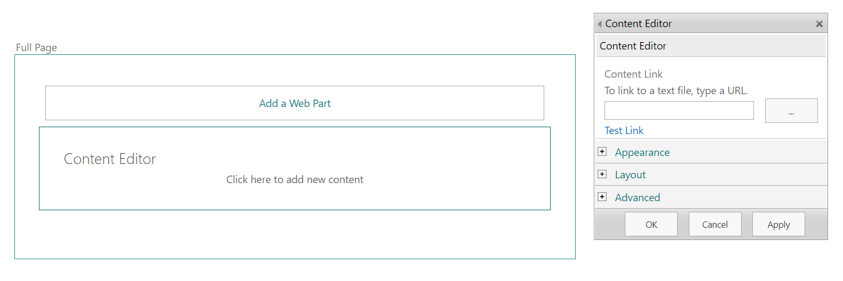

10) Click install and then refresh on appearing dialog

